PROJECT REPORT

UNEARTHING THE ENVIRONMENTAL IMPACT OF HUMAN ACTIVITY:A GLOBAL CO2 EMISSION ANALYSIS

1.INTRODUCTION

1.1 OVERVIEW

Global CO2 emissions refer to the total amount of carbon dioxide gas that is released into the atmosphere from human activities such as burning fossil fuels for energy, industrial processes, transportation, and deforestation. Understanding and analyzing global CO2 emissions is crucial for assessing the impact of human activities on the environment and climate change.

To unearth global CO2 emission analysis, one can start by looking at the data provided by international organizations such as the International Energy Agency (IEA), the United Nations Framework Convention on Climate Change (UNFCCC), and the Global Carbon Project (GCP). These organizations collect and publish data on global CO2 emissions from different sectors and regions of the world, providing insights into the trends, patterns, and drivers of emissions.

1.2 PURPOSE

The purpose of unearthing CO2 emission analysis is to understand the extent and impact of human activities on the environment and climate change. Carbon dioxide is a greenhouse gas that traps heat in the Earth's atmosphere, contributing to global warming and climate change. The burning of fossil fuels for energy and other human activities is a major source of CO2 emissions, and reducing these emissions is crucial to mitigating the negative effects of climate change.

By analyzing global CO2 emissions, researchers, policymakers, and the public can gain insights into the trends, patterns, and drivers of emissions, as well as the potential impact of different policies, technologies, and behavioral changes on emissions. This information can inform the development and implementation of effective climate policies and strategies, as well as guide individual and collective actions to reduce emissions.

2 PROBLEM DEFINITION AND DESIGN THINKING

2.1 EMPATHY MAP



2.2 IDEATION AND BRAINSTORMING MAP



3 RESULT

ACTIVITY AND SCREENSHOT

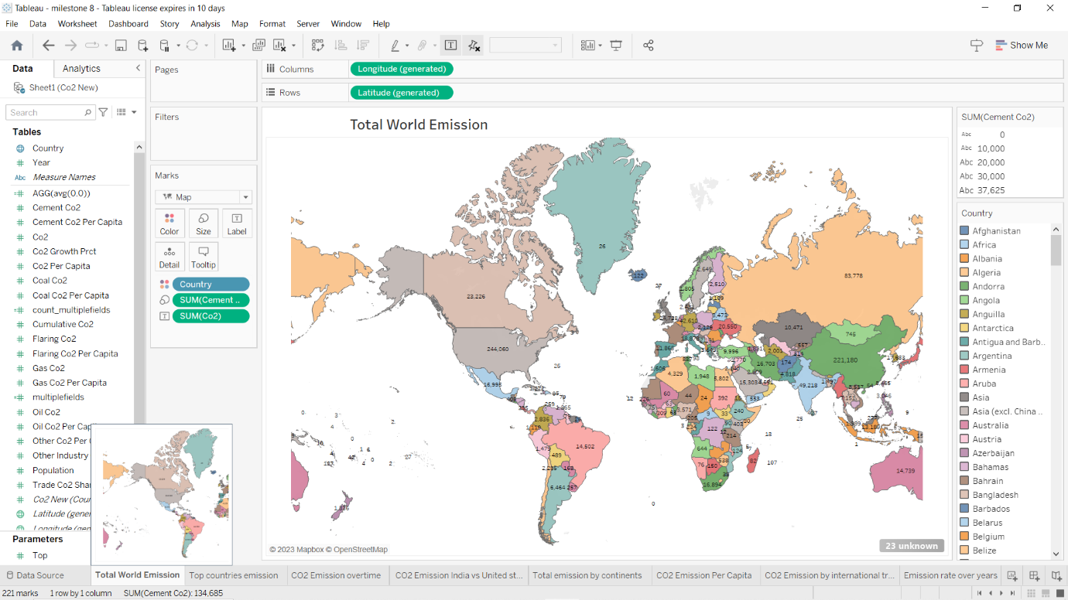

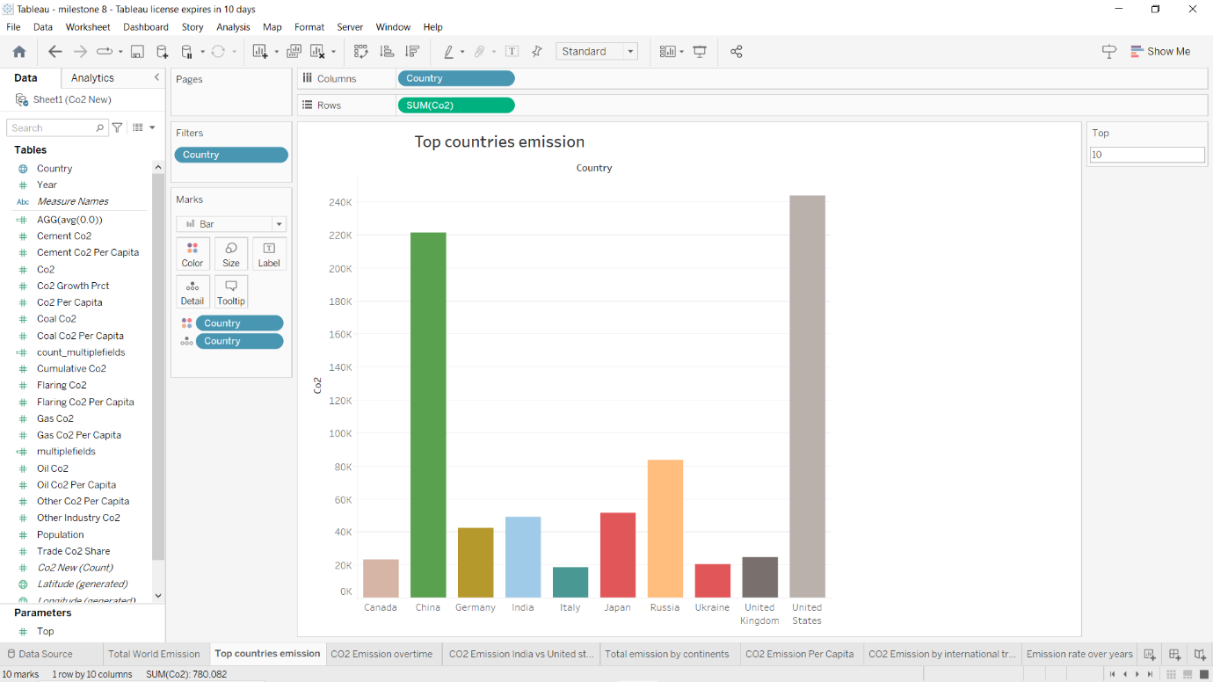

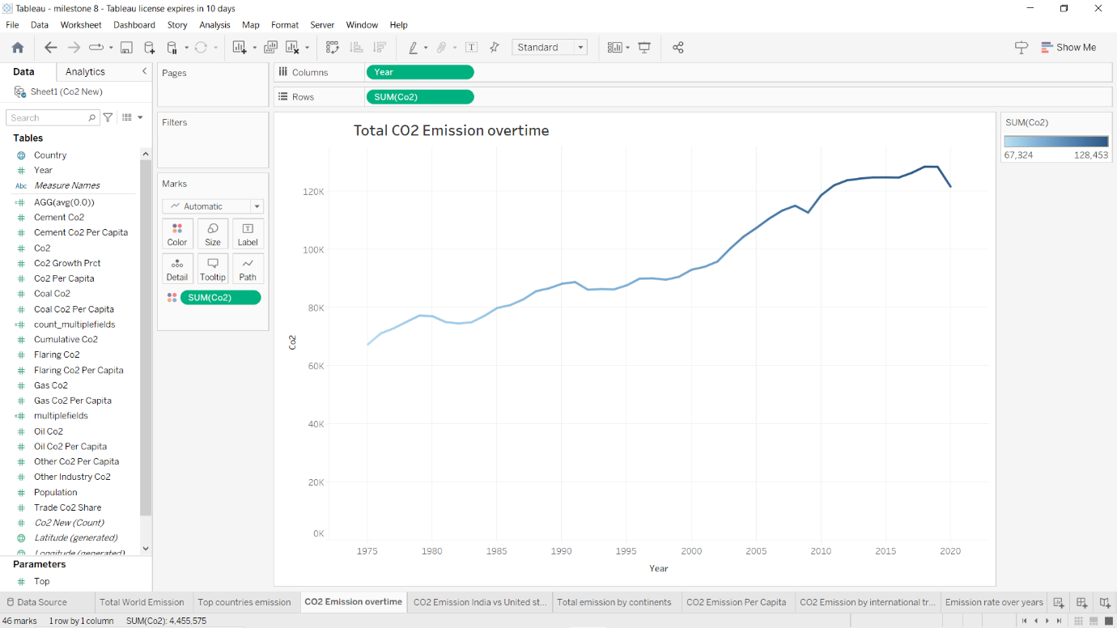

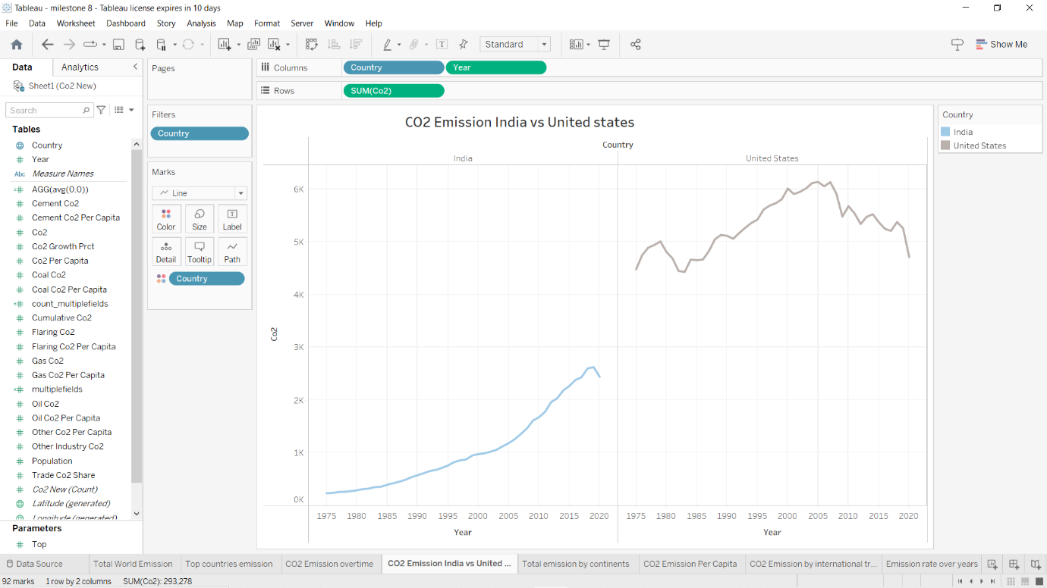

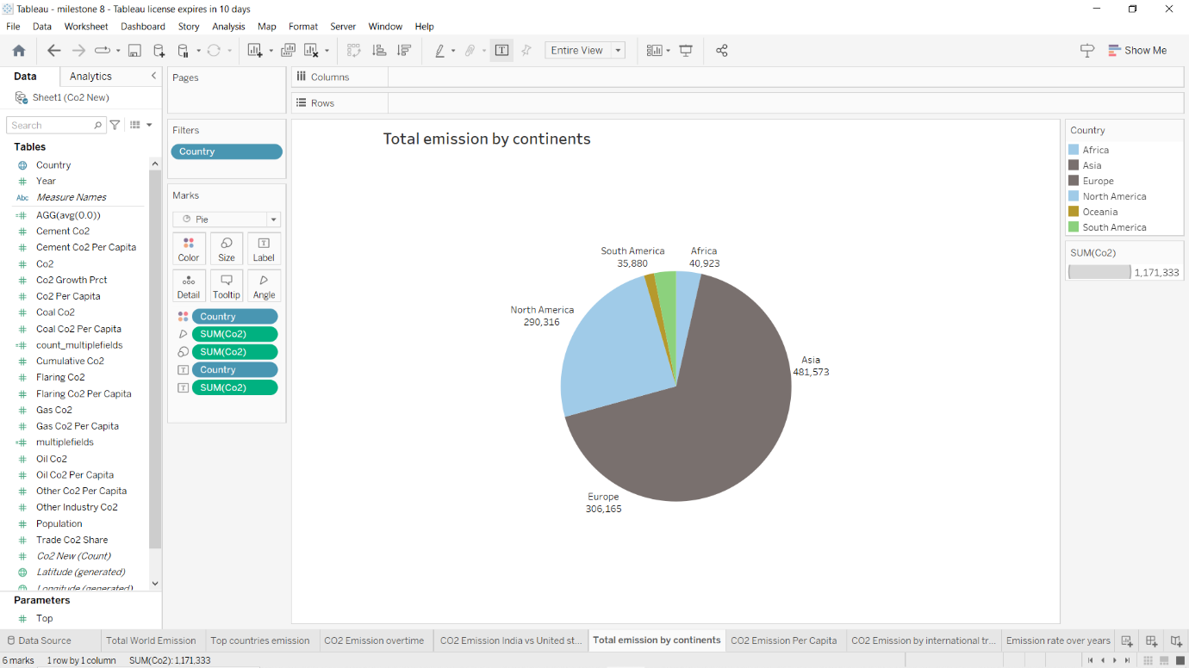

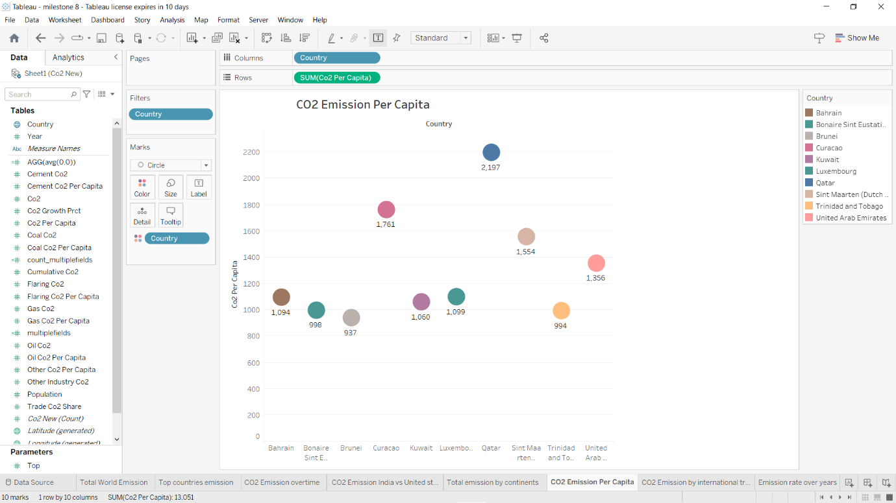

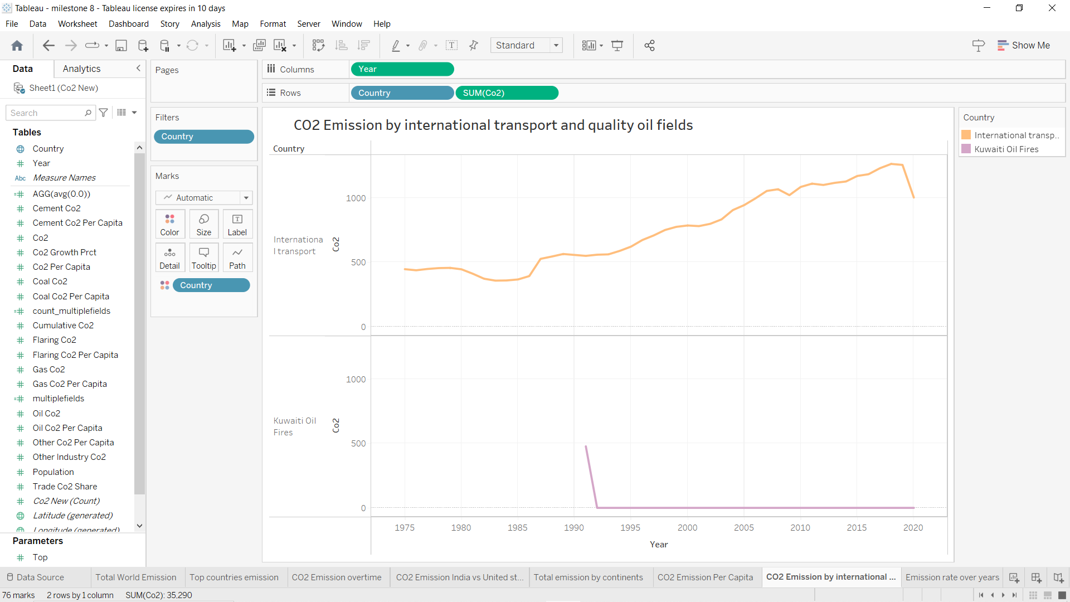

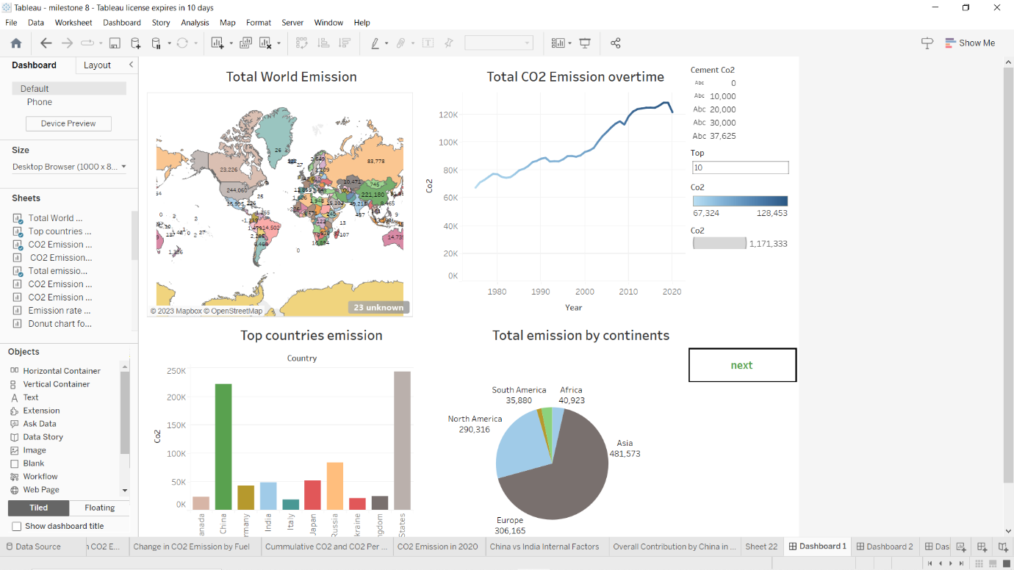

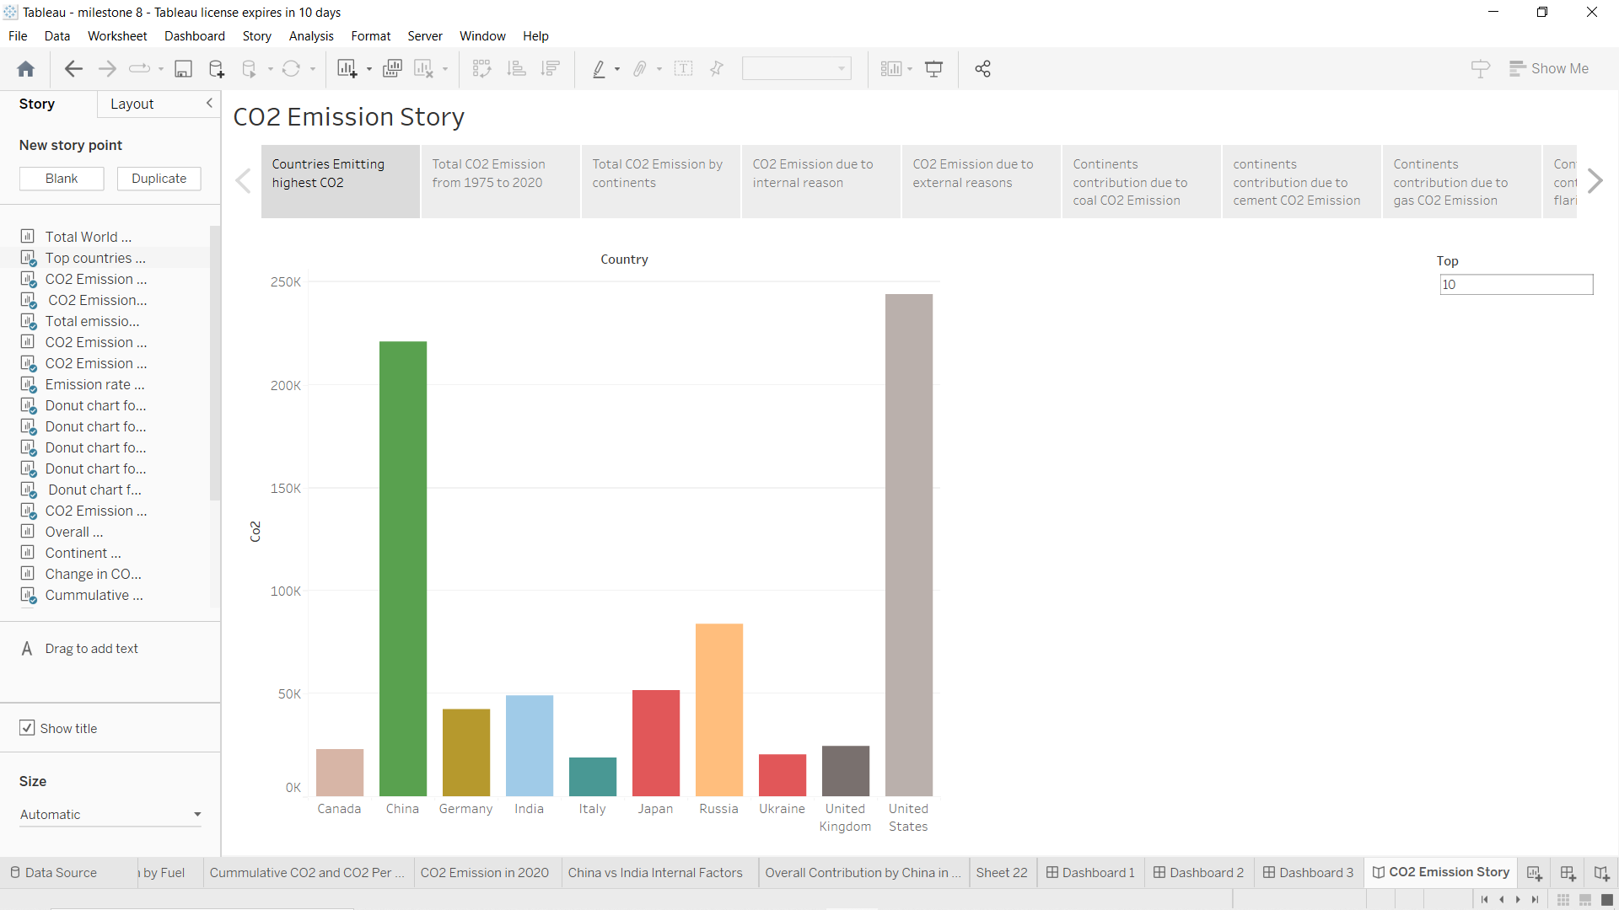

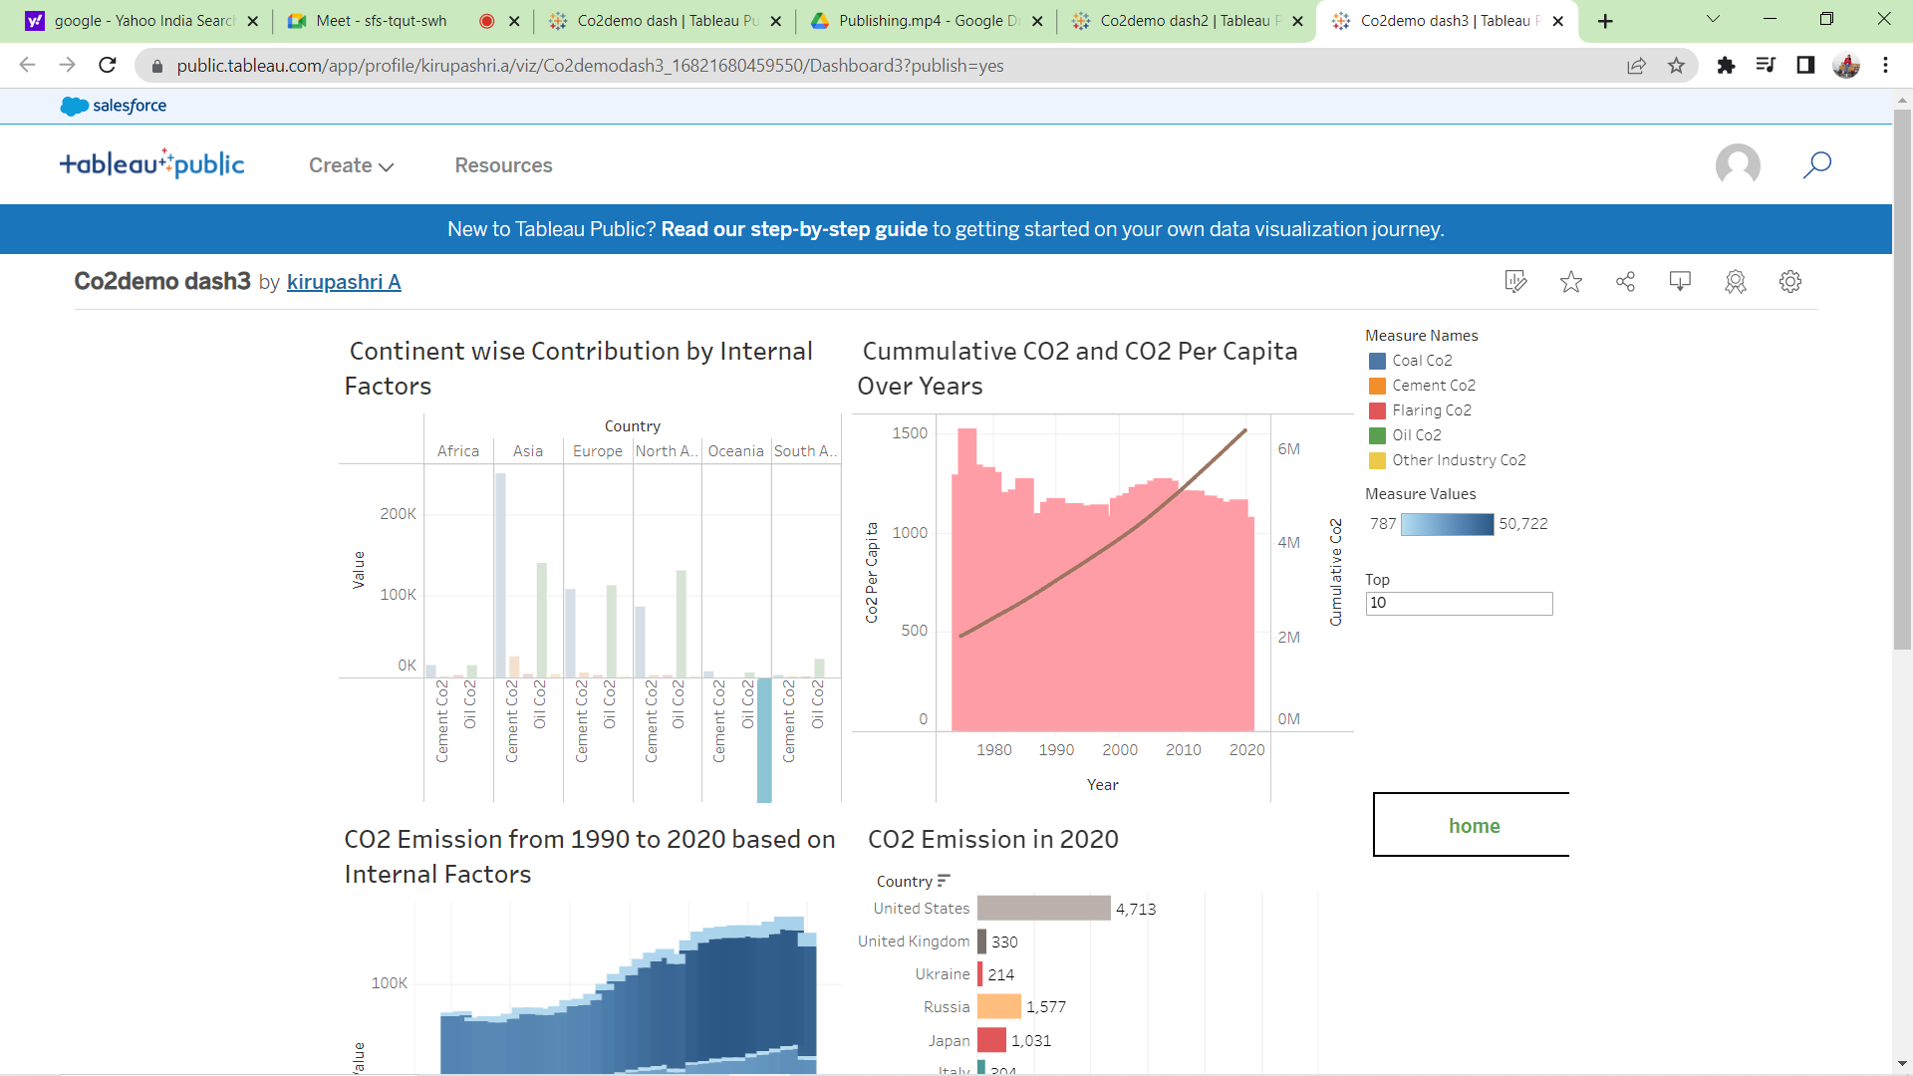

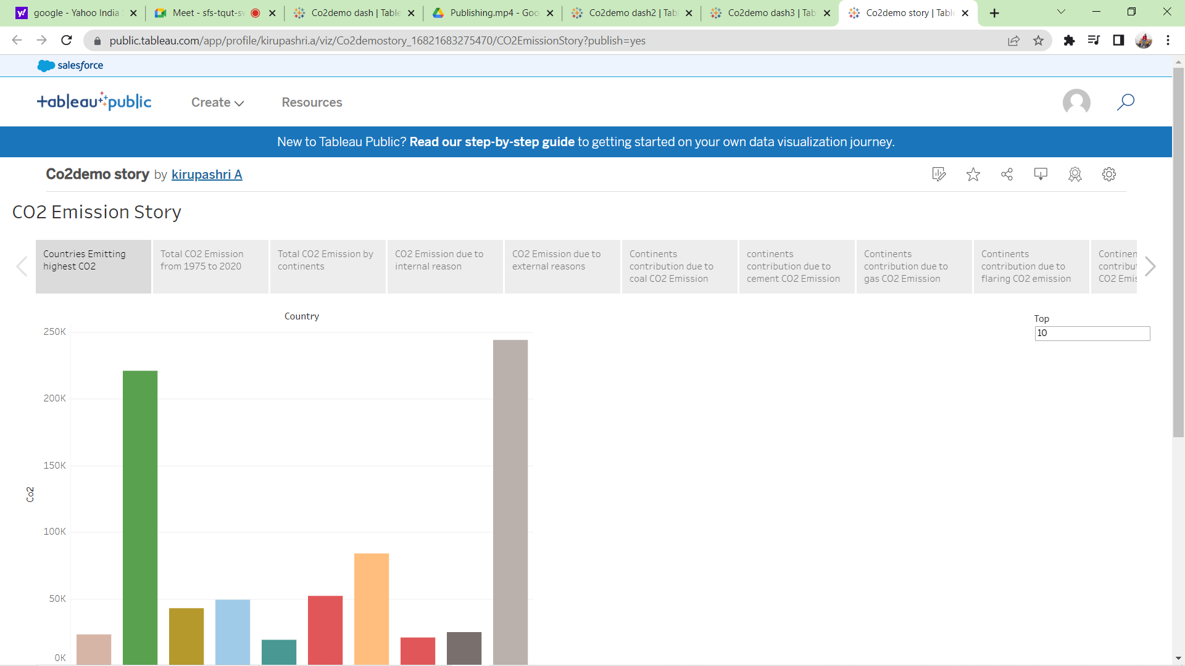

4 ADVANTAGE AND DISADVANTAGE

Advantages of global CO2 emission analysis:

1. Helps in identifying global trends: Global CO2 emission analysis helps to identify the trends of CO2 emissions across different regions, countries, and sectors. This information can be useful for policymakers to develop effective strategies and policies to mitigate the effects of climate change.
2. Encourages transparency: By analyzing global CO2 emissions, governments and industries can better understand their contribution to greenhouse gas emissions. This can lead to increased transparency and accountability in reporting emissions data.
3. Helps in monitoring progress: Regular analysis of global CO2 emissions can help in monitoring the progress made towards reducing emissions. This can motivate countries and industries to take necessary steps to reduce their carbon footprint.

Disadvantages of global CO2 emission analysis:

1. Limited accuracy: Measuring CO2 emissions can be challenging, and different methodologies can lead to different results. Therefore, the accuracy of the data can be limited, which can impact the effectiveness of policies and strategies based on this analysis.
2. Complex calculations: Analyzing global CO2 emissions involves complex calculations and modeling. This requires significant expertise and resources, which may not be available to all countries or organizations.
3. Lack of cooperation: To conduct effective global CO2 emission analysis, cooperation and data-sharing between countries and industries are necessary. However, some countries or industries may be reluctant to share their data, which can limit the accuracy and usefulness of the analysis.

Top of Form

Regenerate response

5 FUTURE SCOPE

1. Improved data collection and analysis: One of the most significant areas of improvement is in the collection and analysis of data. Accurate and detailed data on CO2 emissions from various sources is essential to identifying trends and developing effective policies.
2. Advanced modeling techniques: Advanced modeling techniques, such as machine learning and artificial intelligence, can help researchers to better understand the relationship between CO2 emissions and climate change. These techniques can also help to predict future emissions and climate scenarios.
3. Development of carbon capture and storage technologies: Carbon capture and storage (CCS) technologies offer a promising solution to reducing CO2 emissions. Developing more efficient and cost-effective CCS technologies could significantly reduce the amount of CO2 released into the atmosphere.
4. Renewable energy sources: Investing in renewable energy sources, such as wind and solar power, can reduce the reliance on fossil fuels and help to lower CO2 emissions.
5. International cooperation: Addressing the issue of CO2 emissions requires international cooperation and collaboration. The establishment of global agreements and policies aimed at reducing emissions can help to mitigate the impacts of climate change.

6 THE CONCLUSION

In conclusion, CO2 emission analysis is a crucial area of research that helps us understand the sources, trends, and impacts of carbon dioxide emissions on our planet's climate. It is clear that reducing greenhouse gas emissions, especially CO2, is necessary to mitigate the negative impacts of climate change. In the future, improving data collection and analysis, developing advanced modeling techniques, investing in renewable energy, developing carbon capture and storage technologies, and promoting international cooperation will all be important strategies for reducing CO2 emissions. As individuals, we can also take action by reducing our carbon footprint through lifestyle changes, such as using public transportation, consuming less meat, and reducing energy consumption. Ultimately, by taking collective action and prioritizing sustainable practices, we can work towards a more sustainable and resilient future for our planet.